Calculate the number of employees corresponding to each skill from the table 'employee' which is

loaded in the Demo.

Answer : table created and data loaded in table ‘employee’

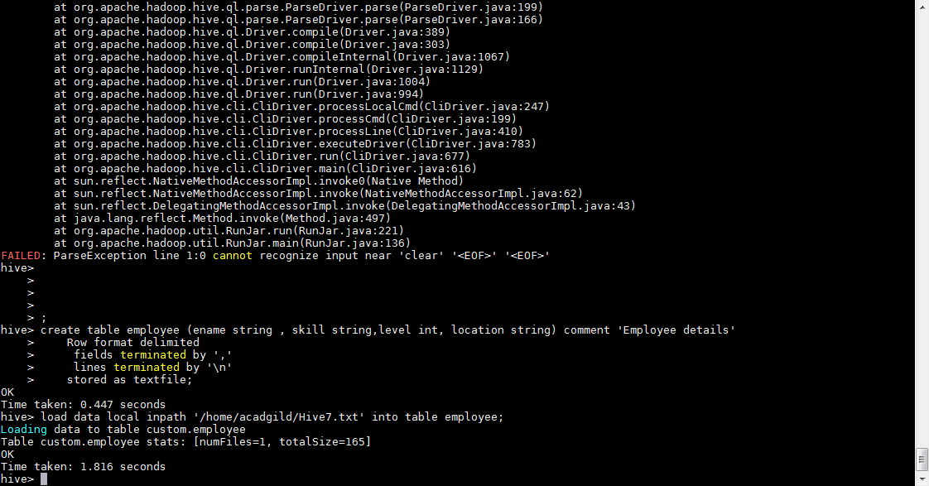

Query : select skill, count(ename) from employee group by skill;

